REST API Documentation

Overview:

1. Student Ranking System
2. Description: System where students are giving exams and based on there result, we need to design APIs which will provide different kind of required data based on different filters.
3. Services: I have added REST APIs for retrieving the 5 different ranking filters

Prerequisites:

1. Python 2.7.15
2. Django 1.8
3. Mysql 5.7
   1. Username: root
   2. Password: data
4. django-cors-headers==2.4.0
5. djangorestframework==3.6.0
6. MySQL-python==1.2.5
7. pycrypto==2.6.1

All Available APIs:

|  |  |  |
| --- | --- | --- |
| **METHOD** | **API** | **Description** |
| GET | /ratings/ | Ranking for all students by standard and term |
| GET | /overall/top/students/standard/ | Overall top 5 by standard and term |
| GET | /bottom/students/standard/ | Bottom 20 students by standard and term |
| GET | /top/students/subjects/ | Top 5 by subjects and term |
| GET | /average/overall/ | Average of all 4 terms by subjects and overall |
| GET | /students/ | All students information/profile |

1. **GET /ratings/ API**

**REQUEST DATA**

Method: GET

Header parameter:

|  |  |  |
| --- | --- | --- |
| **FIELD** | **REQUIRED** | **VALUE** |
| Content-Type | YES | application/json |

URL: /ratings/

**RESPONSE DATA**

Header:

|  |  |
| --- | --- |
| Content-Type | application/json |

Status: 200 OK

Message Body Example:

|  |
| --- |
| {  "Standard 1": {  "Term 1": {  "Rank 4": {  "gained_marks__avg": 73.0,  "studentFK__name": "Aarti"  },  "Rank 5": {  "gained_marks__avg": 67.6667,  "studentFK__name": "Raja"  },  "Rank 1": {  "gained_marks__avg": 89.3333,  "studentFK__name": "Manish"  },  "Rank 2": {  "gained_marks__avg": 88.3333,  "studentFK__name": "Akshta"  },  "Rank 3": {  "gained_marks__avg": 75.6667,  "studentFK__name": "Gaurav"  }  },  "Term 2": {  "Rank 4": {  "gained_marks__avg": 77.3333,  "studentFK__name": "Gaurav"  },  "Rank 5": {  "gained_marks__avg": 72.0,  "studentFK__name": "Raja"  },  "Rank 1": {  "gained_marks__avg": 94.3333,  "studentFK__name": "Akshta"  },  "Rank 2": {  "gained_marks__avg": 85.3333,  "studentFK__name": "Aarti"  },  "Rank 3": {  "gained_marks__avg": 80.6667,  "studentFK__name": "Manish"  }  },  "Term 3": {  "Rank 4": {  "gained_marks__avg": 79.0,  "studentFK__name": "Gaurav"  },  "Rank 5": {  "gained_marks__avg": 60.0,  "studentFK__name": "Raja"  },  "Rank 1": {  "gained_marks__avg": 93.3333,  "studentFK__name": "Manish"  },  "Rank 2": {  "gained_marks__avg": 87.6667,  "studentFK__name": "Akshta"  },  "Rank 3": {  "gained_marks__avg": 82.3333,  "studentFK__name": "Aarti"  }  },  "Term 4": {  "Rank 4": {  "gained_marks__avg": 75.3333,  "studentFK__name": "Akshta"  },  "Rank 5": {  "gained_marks__avg": 49.3333,  "studentFK__name": "Raja"  },  "Rank 1": {  "gained_marks__avg": 91.6667,  "studentFK__name": "Gaurav"  },  "Rank 2": {  "gained_marks__avg": 88.0,  "studentFK__name": "Aarti"  },  "Rank 3": {  "gained_marks__avg": 80.6667,  "studentFK__name": "Manish"  }  }  },  "Standard 2": {  "Term 1": {  "Rank 4": {  "gained_marks__avg": 71.0,  "studentFK__name": "Rahul"  },  "Rank 1": {  "gained_marks__avg": 84.3333,  "studentFK__name": "Suman"  },  "Rank 2": {  "gained_marks__avg": 83.6667,  "studentFK__name": "Nishant"  },  "Rank 3": {  "gained_marks__avg": 74.3333,  "studentFK__name": "Anamika"  }  },  "Term 2": {  "Rank 4": {  "gained_marks__avg": 72.0,  "studentFK__name": "Nishant"  },  "Rank 1": {  "gained_marks__avg": 86.0,  "studentFK__name": "Anamika"  },  "Rank 2": {  "gained_marks__avg": 83.6667,  "studentFK__name": "Suman"  },  "Rank 3": {  "gained_marks__avg": 72.3333,  "studentFK__name": "Rahul"  }  },  "Term 3": {  "Rank 4": {  "gained_marks__avg": 68.3333,  "studentFK__name": "Nishant"  },  "Rank 1": {  "gained_marks__avg": 79.6667,  "studentFK__name": "Rahul"  },  "Rank 2": {  "gained_marks__avg": 79.3333,  "studentFK__name": "Anamika"  },  "Rank 3": {  "gained_marks__avg": 76.6667,  "studentFK__name": "Suman"  }  },  "Term 4": {  "Rank 4": {  "gained_marks__avg": 70.6667,  "studentFK__name": "Rahul"  },  "Rank 1": {  "gained_marks__avg": 87.3333,  "studentFK__name": "Suman"  },  "Rank 2": {  "gained_marks__avg": 73.3333,  "studentFK__name": "Nishant"  },  "Rank 3": {  "gained_marks__avg": 71.6667,  "studentFK__name": "Anamika"  }  }  }  } |

**SAMPLE SCREENSHOT**

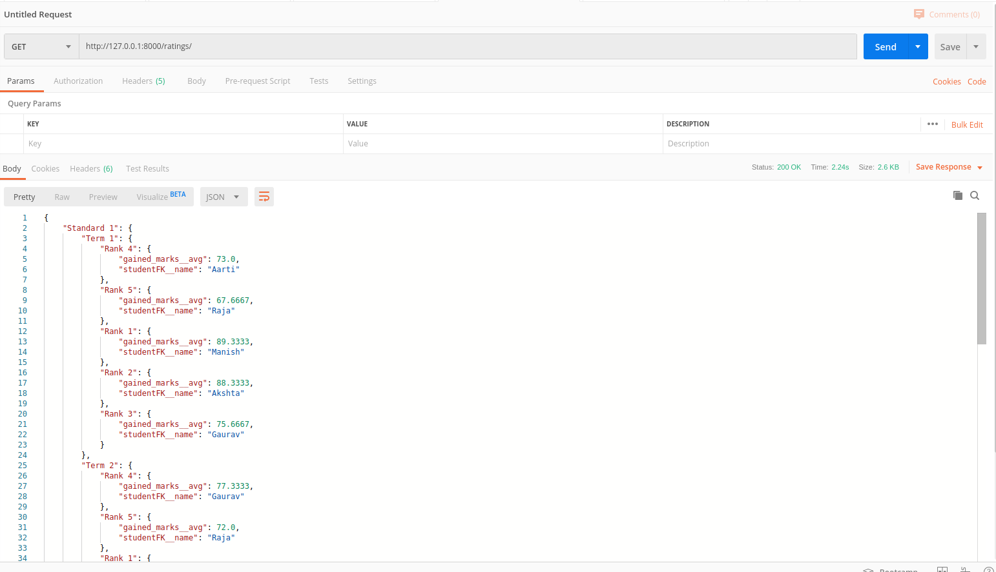

1. **GET /overall/top/students/standard/ API**

**REQUEST DATA**

Method: GET

Header parameter:

|  |  |  |
| --- | --- | --- |
| **FIELD** | **REQUIRED** | **VALUE** |
| Content-Type | YES | application/json |

URL: /overall/top/students/standard/

**RESPONSE DATA**

Header:

|  |  |
| --- | --- |
| Content-Type | application/json |

Status: 200 OK

Message Body Example:

|  |
| --- |
| {  "Standard 1": {  "Term 1": {  "Rank 4": {  "student_name": "Raja",  "overall_marks": 90  },  "Rank 5": {  "student_name": "Aarti",  "overall_marks": 89  },  "Rank 1": {  "student_name": "Akshta",  "overall_marks": 113  },  "Rank 2": {  "student_name": "Manish",  "overall_marks": 108  },  "Rank 3": {  "student_name": "Gaurav",  "overall_marks": 95  }  },  "Term 2": {  "Rank 4": {  "student_name": "Gaurav",  "overall_marks": 95  },  "Rank 5": {  "student_name": "Raja",  "overall_marks": 94  },  "Rank 1": {  "student_name": "Akshta",  "overall_marks": 118  },  "Rank 2": {  "student_name": "Aarti",  "overall_marks": 102  },  "Rank 3": {  "student_name": "Manish",  "overall_marks": 98  }  },  "Term 3": {  "Rank 4": {  "student_name": "Gaurav",  "overall_marks": 95  },  "Rank 5": {  "student_name": "Raja",  "overall_marks": 66  },  "Rank 1": {  "student_name": "Manish",  "overall_marks": 117  },  "Rank 2": {  "student_name": "Akshta",  "overall_marks": 109  },  "Rank 3": {  "student_name": "Aarti",  "overall_marks": 100  }  },  "Term 4": {  "Rank 4": {  "student_name": "Akshta",  "overall_marks": 94  },  "Rank 5": {  "student_name": "Raja",  "overall_marks": 59  },  "Rank 1": {  "student_name": "Gaurav",  "overall_marks": 113  },  "Rank 2": {  "student_name": "Aarti",  "overall_marks": 108  },  "Rank 3": {  "student_name": "Manish",  "overall_marks": 96  }  }  },  "Standard 2": {  "Term 1": {  "Rank 4": {  "student_name": "Rahul",  "overall_marks": 85  },  "Rank 1": {  "student_name": "Nishant",  "overall_marks": 103  },  "Rank 2": {  "student_name": "Suman",  "overall_marks": 103  },  "Rank 3": {  "student_name": "Anamika",  "overall_marks": 93  }  },  "Term 2": {  "Rank 4": {  "student_name": "Rahul",  "overall_marks": 89  },  "Rank 1": {  "student_name": "Anamika",  "overall_marks": 106  },  "Rank 2": {  "student_name": "Suman",  "overall_marks": 102  },  "Rank 3": {  "student_name": "Nishant",  "overall_marks": 90  }  },  "Term 3": {  "Rank 4": {  "student_name": "Nishant",  "overall_marks": 89  },  "Rank 1": {  "student_name": "Rahul",  "overall_marks": 98  },  "Rank 2": {  "student_name": "Anamika",  "overall_marks": 96  },  "Rank 3": {  "student_name": "Suman",  "overall_marks": 94  }  },  "Term 4": {  "Rank 4": {  "student_name": "Anamika",  "overall_marks": 88  },  "Rank 1": {  "student_name": "Suman",  "overall_marks": 109  },  "Rank 2": {  "student_name": "Nishant",  "overall_marks": 93  },  "Rank 3": {  "student_name": "Rahul",  "overall_marks": 88  }  }  }  } |

**SAMPLE SCREENSHOT**

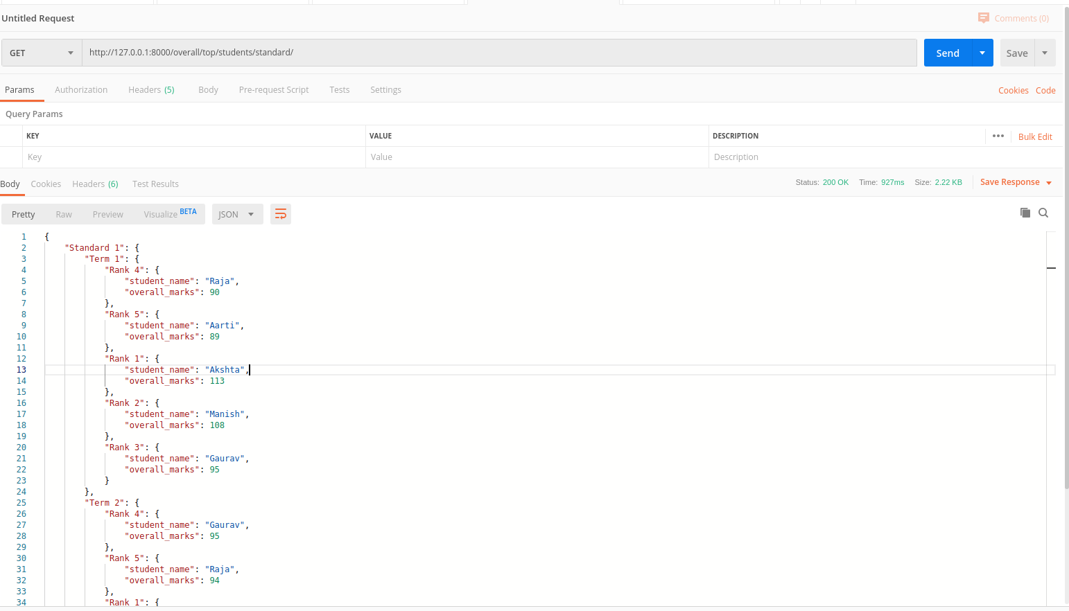

1. **GET /bottom/students/standard/ API**

**REQUEST DATA**

Method: GET

Header parameter:

|  |  |  |
| --- | --- | --- |
| **FIELD** | **REQUIRED** | **VALUE** |
| Content-Type | YES | application/json |

URL: /bottom/students/standard/

**RESPONSE DATA**

Header:

|  |  |
| --- | --- |
| Content-Type | application/json |

Status: 200 OK

Response Body Example:

|  |
| --- |
| {  "Standard 1": {  "Term 1": {  "Rank 4": {  "gained_marks__avg": 73.0,  "studentFK__name": "Aarti"  },  "Rank 5": {  "gained_marks__avg": 67.6667,  "studentFK__name": "Raja"  },  "Rank 1": {  "gained_marks__avg": 89.3333,  "studentFK__name": "Manish"  },  "Rank 2": {  "gained_marks__avg": 88.3333,  "studentFK__name": "Akshta"  },  "Rank 3": {  "gained_marks__avg": 75.6667,  "studentFK__name": "Gaurav"  }  },  "Term 2": {  "Rank 4": {  "gained_marks__avg": 77.3333,  "studentFK__name": "Gaurav"  },  "Rank 5": {  "gained_marks__avg": 72.0,  "studentFK__name": "Raja"  },  "Rank 1": {  "gained_marks__avg": 94.3333,  "studentFK__name": "Akshta"  },  "Rank 2": {  "gained_marks__avg": 85.3333,  "studentFK__name": "Aarti"  },  "Rank 3": {  "gained_marks__avg": 80.6667,  "studentFK__name": "Manish"  }  },  "Term 3": {  "Rank 4": {  "gained_marks__avg": 79.0,  "studentFK__name": "Gaurav"  },  "Rank 5": {  "gained_marks__avg": 60.0,  "studentFK__name": "Raja"  },  "Rank 1": {  "gained_marks__avg": 93.3333,  "studentFK__name": "Manish"  },  "Rank 2": {  "gained_marks__avg": 87.6667,  "studentFK__name": "Akshta"  },  "Rank 3": {  "gained_marks__avg": 82.3333,  "studentFK__name": "Aarti"  }  },  "Term 4": {  "Rank 4": {  "gained_marks__avg": 75.3333,  "studentFK__name": "Akshta"  },  "Rank 5": {  "gained_marks__avg": 49.3333,  "studentFK__name": "Raja"  },  "Rank 1": {  "gained_marks__avg": 91.6667,  "studentFK__name": "Gaurav"  },  "Rank 2": {  "gained_marks__avg": 88.0,  "studentFK__name": "Aarti"  },  "Rank 3": {  "gained_marks__avg": 80.6667,  "studentFK__name": "Manish"  }  }  },  "Standard 2": {  "Term 1": {  "Rank 4": {  "gained_marks__avg": 71.0,  "studentFK__name": "Rahul"  },  "Rank 1": {  "gained_marks__avg": 84.3333,  "studentFK__name": "Suman"  },  "Rank 2": {  "gained_marks__avg": 83.6667,  "studentFK__name": "Nishant"  },  "Rank 3": {  "gained_marks__avg": 74.3333,  "studentFK__name": "Anamika"  }  },  "Term 2": {  "Rank 4": {  "gained_marks__avg": 72.0,  "studentFK__name": "Nishant"  },  "Rank 1": {  "gained_marks__avg": 86.0,  "studentFK__name": "Anamika"  },  "Rank 2": {  "gained_marks__avg": 83.6667,  "studentFK__name": "Suman"  },  "Rank 3": {  "gained_marks__avg": 72.3333,  "studentFK__name": "Rahul"  }  },  "Term 3": {  "Rank 4": {  "gained_marks__avg": 68.3333,  "studentFK__name": "Nishant"  },  "Rank 1": {  "gained_marks__avg": 79.6667,  "studentFK__name": "Rahul"  },  "Rank 2": {  "gained_marks__avg": 79.3333,  "studentFK__name": "Anamika"  },  "Rank 3": {  "gained_marks__avg": 76.6667,  "studentFK__name": "Suman"  }  },  "Term 4": {  "Rank 4": {  "gained_marks__avg": 70.6667,  "studentFK__name": "Rahul"  },  "Rank 1": {  "gained_marks__avg": 87.3333,  "studentFK__name": "Suman"  },  "Rank 2": {  "gained_marks__avg": 73.3333,  "studentFK__name": "Nishant"  },  "Rank 3": {  "gained_marks__avg": 71.6667,  "studentFK__name": "Anamika"  }  }  }  } |

**SAMPLE SCREENSHOT**

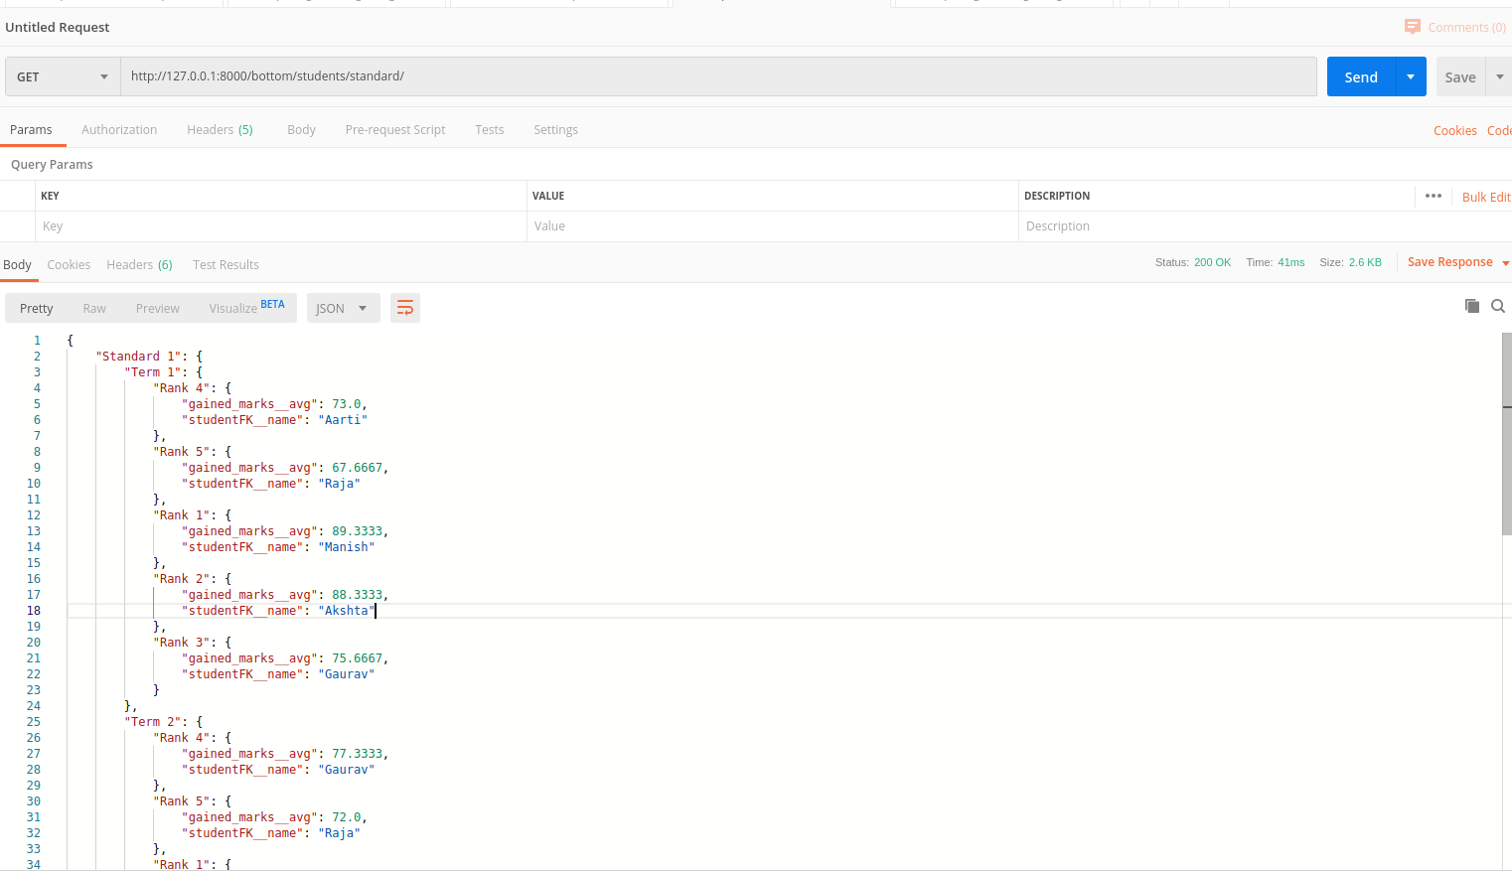

1. **GET /top/students/subjects API**

**REQUEST DATA**

Method: GET

Header parameter:

|  |  |  |
| --- | --- | --- |
| **FIELD** | **REQUIRED** | **VALUE** |
| Content-Type | YES | application/json |

URL: /top/students/subjects/

**RESPONSE DATA**

Header:

|  |  |
| --- | --- |
| Content-Type | application/json |

Status: 200 OK

Response Body Example:

|  |
| --- |
| {  "Science": {  "Term 1": {  "Rank 4": {  "gained_marks__avg": 77.0,  "studentFK__name": "Nishant"  },  "Rank 5": {  "gained_marks__avg": 76.0,  "studentFK__name": "Raja"  },  "Rank 1": {  "gained_marks__avg": 99.0,  "studentFK__name": "Manish"  },  "Rank 2": {  "gained_marks__avg": 99.0,  "studentFK__name": "Akshta"  },  "Rank 3": {  "gained_marks__avg": 92.0,  "studentFK__name": "Suman"  }  },  "Term 2": {  "Rank 4": {  "gained_marks__avg": 80.0,  "studentFK__name": "Gaurav"  },  "Rank 5": {  "gained_marks__avg": 80.0,  "studentFK__name": "Aarti"  },  "Rank 1": {  "gained_marks__avg": 99.0,  "studentFK__name": "Akshta"  },  "Rank 2": {  "gained_marks__avg": 90.0,  "studentFK__name": "Anamika"  },  "Rank 3": {  "gained_marks__avg": 81.0,  "studentFK__name": "Suman"  }  },  …,  …  } |

**SAMPLE SCREENSHOT**

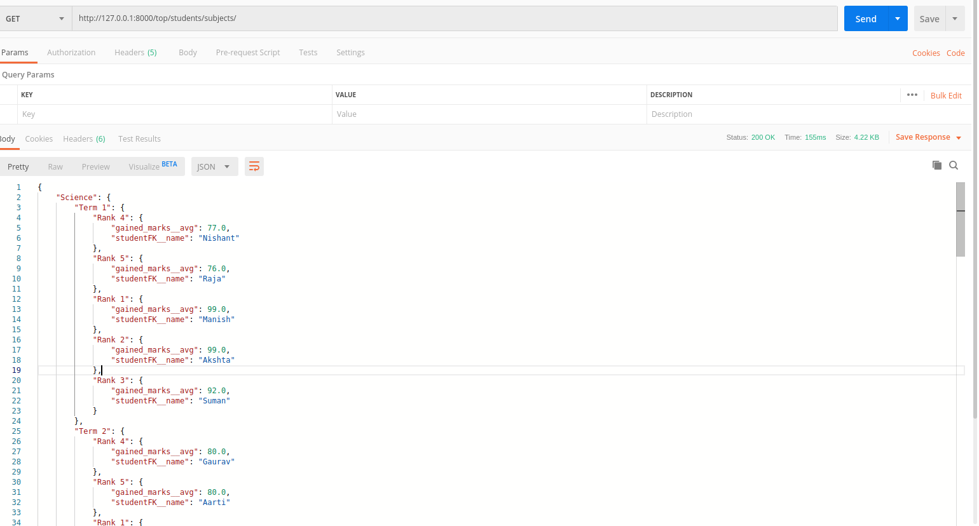

1. **GET /average/overall/ API**

**REQUEST DATA**

Method: GET

Header parameter:

|  |  |  |
| --- | --- | --- |
| **FIELD** | **REQUIRED** | **VALUE** |
| Content-Type | YES | application/json |

URL: /average/overall/

**RESPONSE DATA**

Header:

|  |  |
| --- | --- |
| Content-Type | application/json |

Status: 200 OK

Message Body Example:

|  |
| --- |
| {  "Science": {  "Term 1": 40,  "Term 2": 39,  "Term 3": 37,  "Term 4": 38  },  "Social": {  "Term 1": 18,  "Term 2": 20,  "Term 3": 21,  "Term 4": 19  },  "Maths": {  "Term 1": 38,  "Term 2": 39,  "Term 3": 37,  "Term 4": 37  },  "SecondLang": {  "Term 1": 0,  "Term 2": 0,  "Term 3": 0,  "Term 4": 0  },  "Geography": {  "Term 1": 0,  "Term 2": 0,  "Term 3": 0,  "Term 4": 0  },  "FirstLang": {  "Term 1": 0,  "Term 2": 0,  "Term 3": 0,  "Term 4": 0  }  } |

**SAMPLE SCREENSHOT**

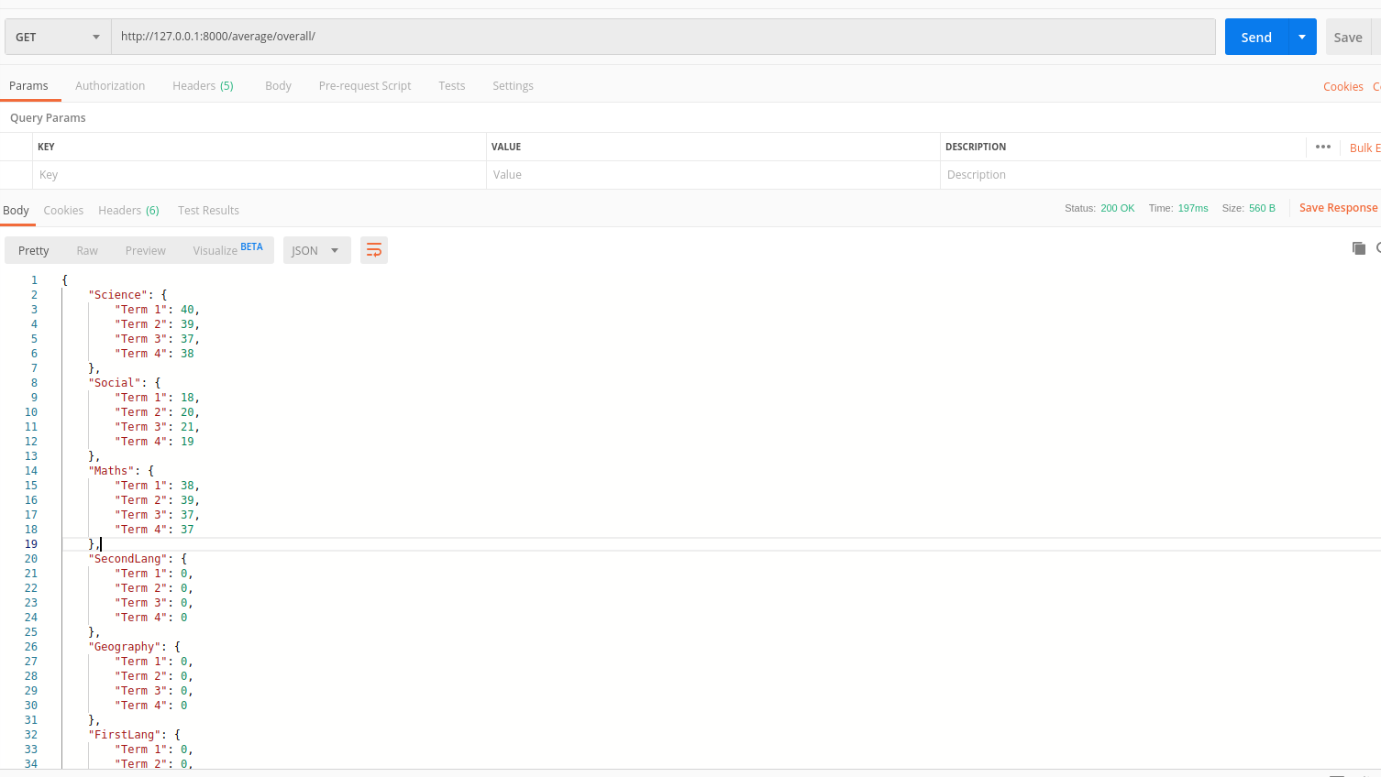

**HOW TO RUN PROJECT LOCALLY**

1. Setup mysql connection locally
   1. DB Name: school
   2. DB user: root
   3. DB password: data
2. git clone <https://github.com/Gaurav1990/online_book_store.git>
3. (optional) if we want to insert dummy data then  
   mysql –u root –p school < testdb.sql
4. cd <project_dir>
5. python manage.py migrate (to create tables in local)
6. python manage.py runserver (to run locally)
7. Use POSTMAN or any other API Handling tool
8. Run above APIs mentioned in the Documenation